**COMPOSITE SCREENS**

**Multiple but combined screens**

**Browser window divided into frames**

**Each frame contains a valid type of application**

* + ENQ: is an Enquiry.
  + TXN: is a contract screen (eg Version)
  + UTILITY: is a routine or a banner
  + TAB: is a tabbed screen.
  + COS: is a composite screen.
  + MENU: is a menu.
  + URL: is a URL.
  + BLANK: This part of the frame remains blank

**Main fields in EB.COMPOSITE.SCREEN**

* + CONTENT.TYPE

* + COLS

Number of columns occupied by frame

* + ROWS

Number of rows occupied by frame

* + NAME
  + SCROLLING
  + TARGET
  + CONTENT

Actual content of frame

* + ITEMS

ALL, NOENQ, ENQ,

**WORKSHOP1:**

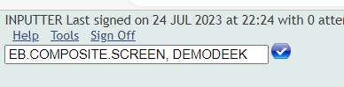

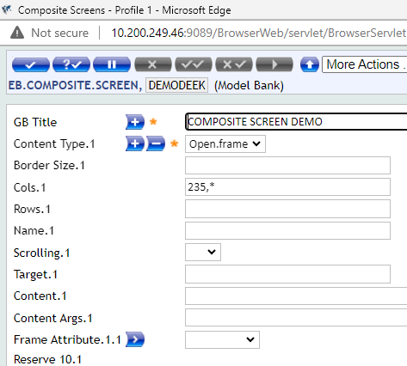

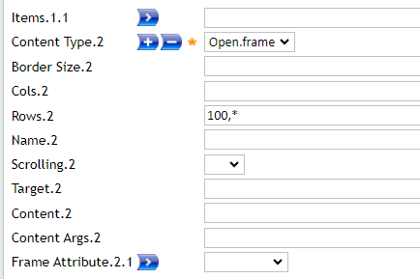

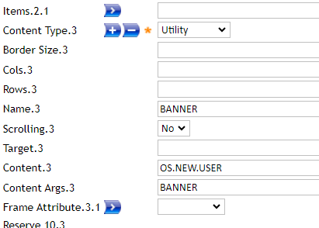

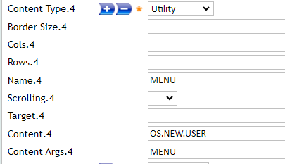

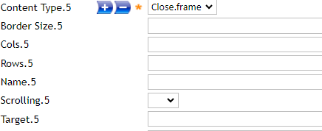

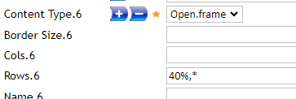

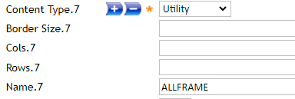

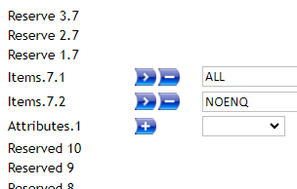

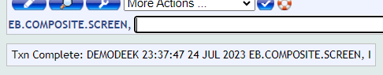

OUTPUT:

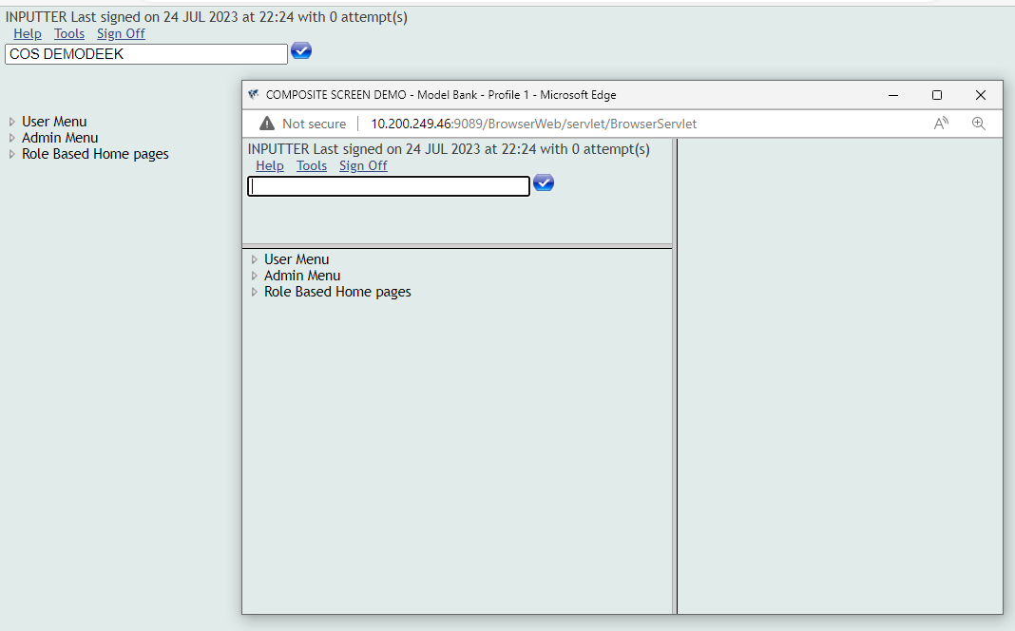

**WORKSHOP 2:**

Split screen in half VERTICAL, with first half having enquiry for account.

EB.COMPOSITE.SCREEN TESTDEEK'

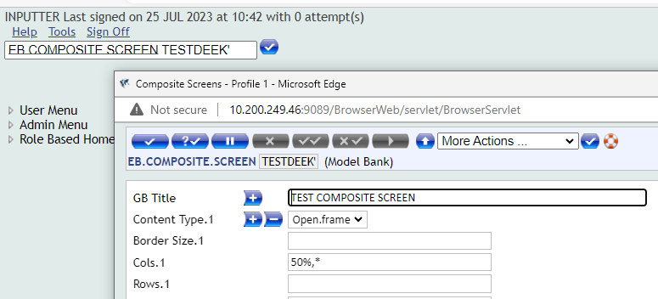

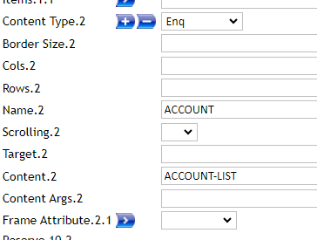

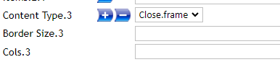

COMMIT, FROM AUTHOR, AUTJORISE THIS RECORD,

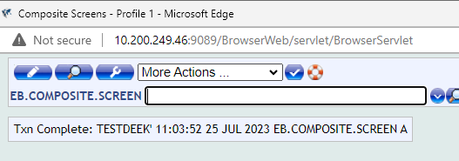

**OUTPUT**

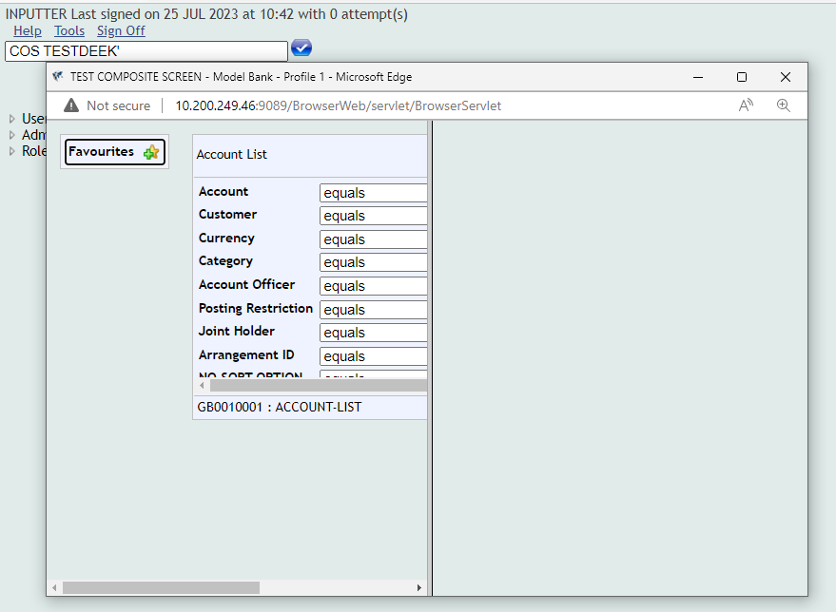

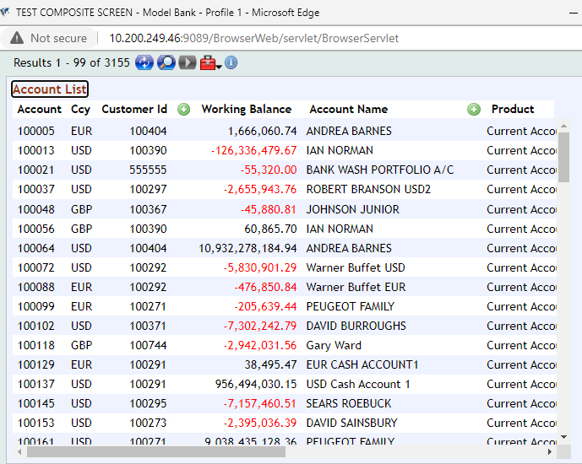

**WORKSHOP 3:**

Split screen in half HORIZONTAL, with first half having VERSION for input account.

EB.COMPOSITE.SCREEN, TESTDEEK2

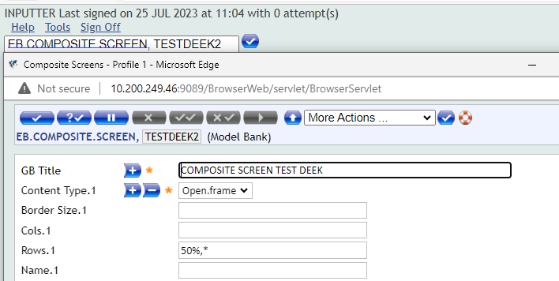

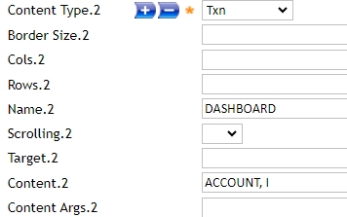

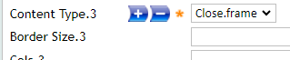

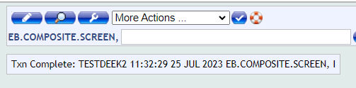

OUTPUT:

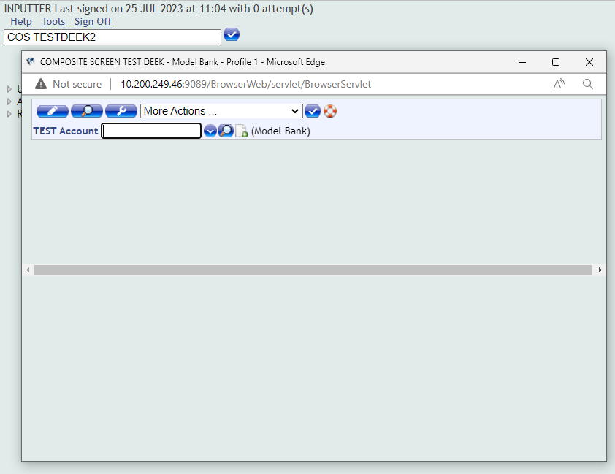

**WORKSOP 4:**

USE Content.Type options like – URL,MENU,BLANK

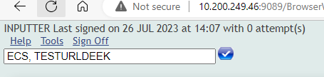

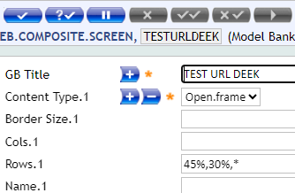

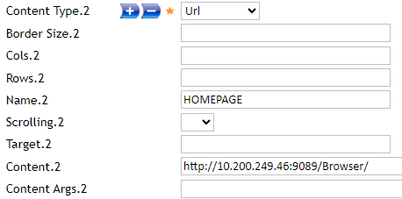

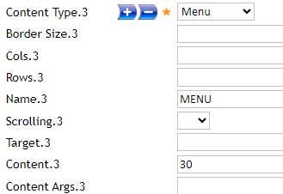

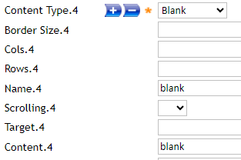



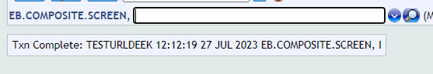

OUTPUT:

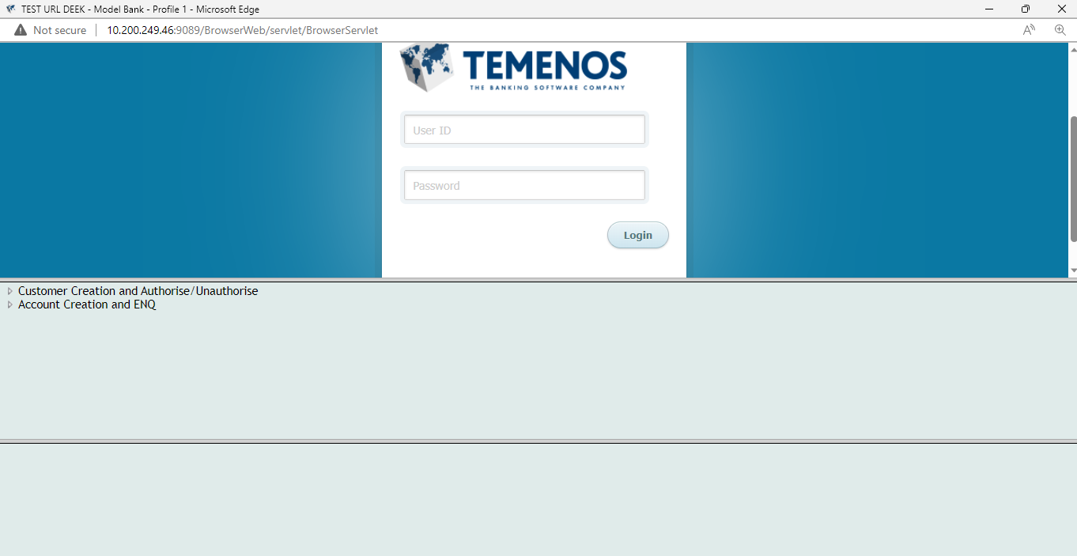

**WORKSHOP 5**

ECS, TESTCONTENTDEEK

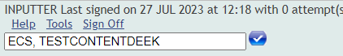

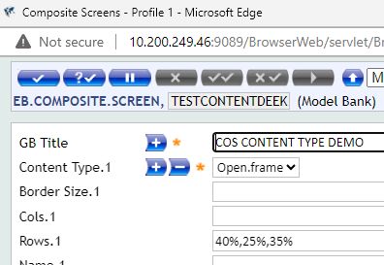

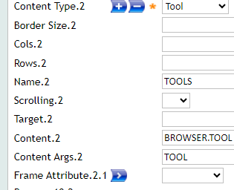

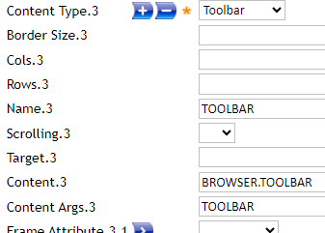

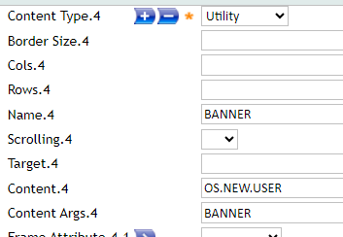

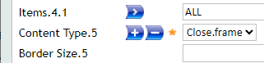

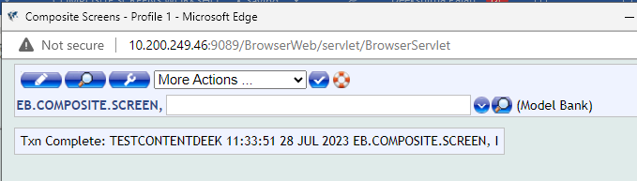

OUTPUT:

